6. AMALIY ISHI
Mavzu: AJAX asosida tarmoq dasturini yaratish

Ishning maqsadi:
Java dasturlash XMLHttpRequest obyektidan foydalanib AJAX asosida tarmoq dasturini yaratish.
Topshiriq:
Talaba Amaliy ishi uchun shaxsiy topshiriq oladi. Bu topshiriq bo‘yicha talaba AJAX asosida tarmoq dasturini yaratadi. Har bir talaba uchun shaxsiy topshiriq beriladi.
Nazariy qism:
AJAX (Asinxron JavaScript va XML) bu ko‘plab veb-texnologiyalardan foydalangan holda kliyent tomonida asinxron veb-ilovalarni yaratuvchi vositalar to‘plami. Ajax yordamida veb-ilovalar sahifasining ko‘rinishi va ishiga xalaqit bermasdan ma’lumotni serverdan (fonda) asinxron ravishda yuborishi va qabul qilishi mumkin. Ajax veb-sahifalar tarkibini dinamik ravishda butun sahifani qayta yuklamasdan o‘zgartirishga imkon beradi.
AJAX imkoniyatlari:
- Sahifani qayta yuklamasdan veb-sahifani yangilash
- Sahifa yuklangandan so‘ng serverdan ma’lumotlarni so‘rash
- Sahifa yuklangandan so‘ng serverdan ma’lumotlarni qabul qilish
- Serverga ma’lumotlarni orqa fonda yuborish
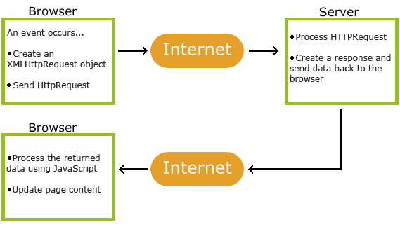
6.1- rasm. AJA XMLHttpRequest obyekti.

Barcha zamonaviy brauzerlar XMLHttpRequest obyektini qo‘llab-quvvatlaydi.
Fonda veb-server bilan ma’lumot almashish uchun XMLHttpRequest obyektidan foydalanish mumkin. Bu shuni anglatadiki, butun sahifani qayta yuklamasdan, veb-sahifaning qismlarini yangilash mumkin.
var xhttp = new XMLHttpRequest();
Xning ishlashi
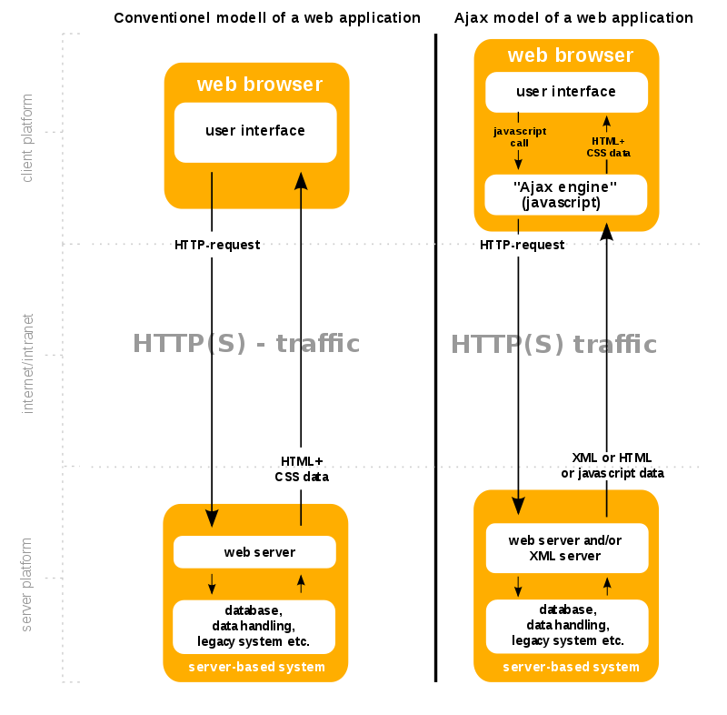
6.2- rasm. Ajax texnologiyasi asosida Veb ilova

6.1- jadval
XMLHttpRequest obyekt metodlari
Metod | Tavsifi
new XMLHttpRequest() | Creates a new XMLHttpRequest object
abort() | Cancels the current request
getAllResponseHeaders() | Returns header information
getResponseHeader() | Returns specific header information
open(method, url, async, user, psw) | Specifies the request  method: the request type GET or POST  url: the file location  async: true (asynchronous) or false (synchronous)  user: optional user name  psw: optional password
send() | Sends the request to the server  Used for GET requests
send(string) | Sends the request to the server.  Used for POST requests
setRequestHeader() | Adds a label/value pair to the header to be sent
Serverga so‘rov jo‘natish:
- xhttp.open("GET", "ajax_info.txt", true);
xhttp.send();
- xhttp.open("POST", "demo_post.asp", true);
xhttp.send();
- xhttp.open("POST", "ajax_test.asp", true);
xhttp.setRequestHeader("Content-type", "application/x-www-form-urlencoded");
xhttp.send("fname=Henry&lname=Ford");
- xhttp.open("GET", "ajax_info.txt", false);
xhttp.send();

6.2- jadval
Server javobi
Property | Description
onreadystatechange | Defines a function to be called when the readyState property changes
readyState | Holds the status of the XMLHttpRequest.  0: request not initialized  1: server connection established  2: request received  3: processing request  4: request finished and response is ready
status | 200: "OK"  403: "Forbidden"  404: "Page not found"  ……
statusText | Returns the status-text (e.g. "OK" or "Not Found")

Server javobi:
function loadDoc() {
var xhttp = new XMLHttpRequest();
xhttp.onreadystatechange = function() {
if (this.readyState == 4 && this.status == 200) {
document.getElementById("demo").innerHTML =
this.responseText;
}
};
xhttp.open("GET", "ajax_info.txt", true);
xhttp.send();
}
Ishni bajarish tartibi:
Ishni Eclipse yoki NetBeans IDE integrallashgan ishlab chiqarish muhitini yuklash bilan boshlaymiz.
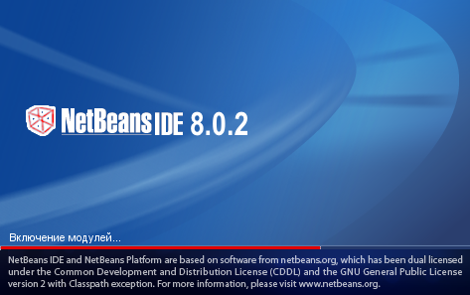
6.3- rasm. NetBeans IDE ishga tushish jarayoni

Quyidagi rasmda NetBeans IDE muhitining asosiy darchasi yuklangan.
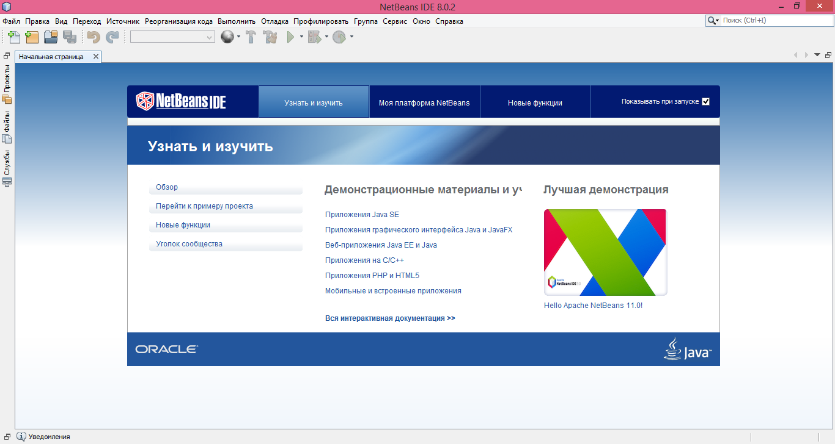
6.4- rasm. NetBeans IDE muhiti asosiy darchasi

Shundan so‘ng “Файл” menyusidan “Создать проект” bo‘limi tanlanganda quyidagi rasmdagi darcha paydo bo‘ladi. Ushbu darchadan “Категории” bo‘limidan JavaWeb tanlanib “Далее” tugmasi bosiladi.

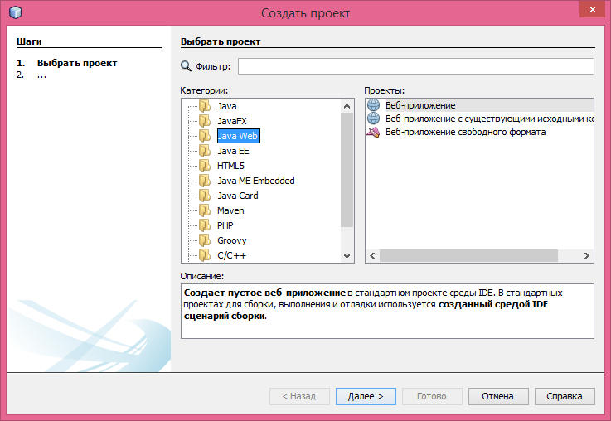
6.5- rasm. NetBeans IDE “Создать проект” darchasi

Keyingi qadam “Новый Веб-приложение” dasturiga o‘tiladi. Ushbu darchaning “Имя проекта” maydoniga proyekt nomi sifatida “Talabaning_Ismi_Web” kiritilib “Далее” tugmasi bosiladi.

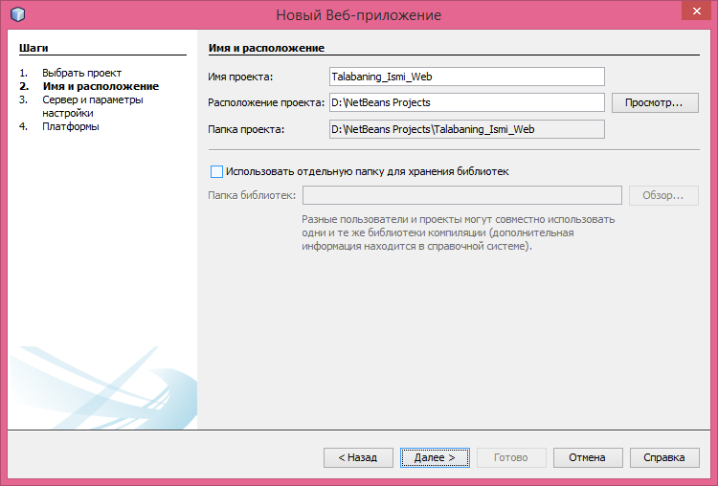
6.6- rasm. NetBeans IDE muhiti “Новый Веб-приложение” darchasi
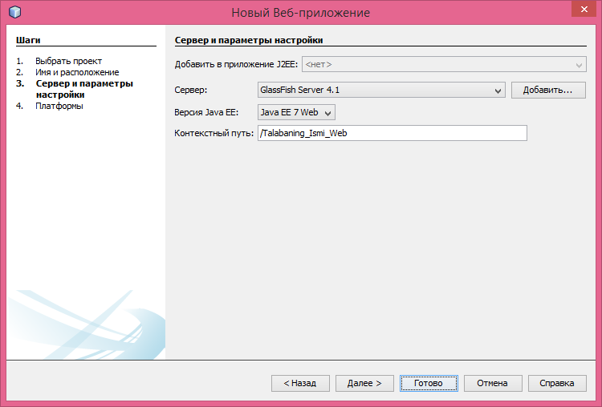
6.7- rasm. NetBeans IDE muhiti “Новый Веб-приложение” darchasi

So‘ng 6.7- rasmdagi darchadan “Готово” tugmasi bosiladi.

Shundan so‘ng yaratilgan loyihaning ustiga sichqonchaning o‘ng tugmasi bir marta bosiladi va paydo bo‘lgan kontekst menyudan “Новый → HTML…” tanlanadi.

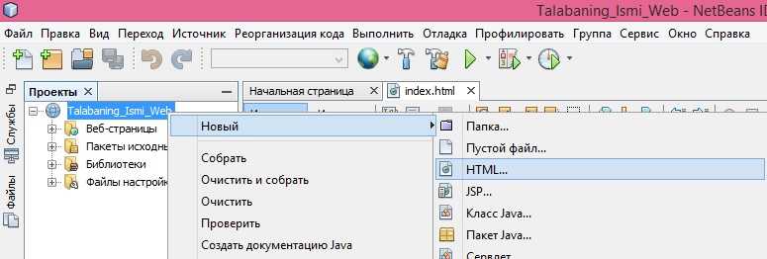
6.8- rasm. NetBeans IDE muhiti HTML fayl yaratish

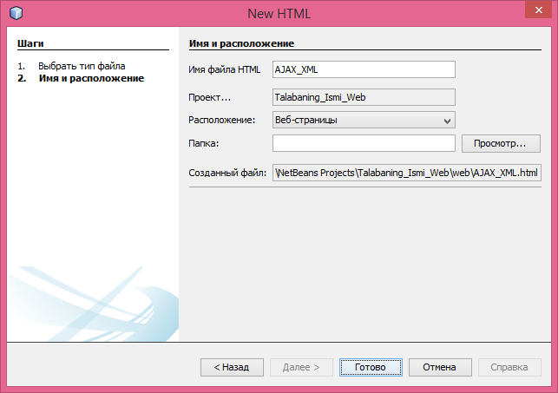
6.9- rasm. NetBeans IDE muhiti HTML fayl yaratish darchasi

“New HTML” darchasining “Имя файла HTML” maydoniga “AJAX_XML” kiritilib “Готово” tugmasi bosiladi. Yaratilgan AJAX_XML.html fayliga quyidagi HTML+CSS+JavaScript kod kiritiladi.
<!DOCTYPE html>
<html>
<style>
table,th,td {
border : 1px solid black;
border-collapse: collapse;
}
th,td {
padding: 5px;
}
</style>
<body>
<h2>The XMLHttpRequest Object</h2>
<button type="button" onclick="loadDoc()">Get my CD collection</button>
<br><br>
<table id="demo"></table>
<script>
function loadDoc() {
var xhttp = new XMLHttpRequest();
xhttp.onreadystatechange = function () {
if (this.readyState == 4 && this.status == 200) {
myFunction(this);
}
};
xhttp.open("GET", "cd_catalog.xml", true);
xhttp.send();
}
function myFunction(xml) {
var i;
var xmlDoc = xml.responseXML;
var table = "<tr><th>Artist</th><th>Title</th></tr>";
var x = xmlDoc.getElementsByTagName("CD");
for (i = 0; i < x.length; i++) {
table += "<tr><td>" +
x[i].getElementsByTagName("ARTIST")[0].childNodes[0].nodeValue +
"</td><td>" +
x[i].getElementsByTagName("TITLE")[0].childNodes[0].nodeValue +
"</td></tr>";
}
document.getElementById("demo").innerHTML = table;
}
</script>
</body>
</html>
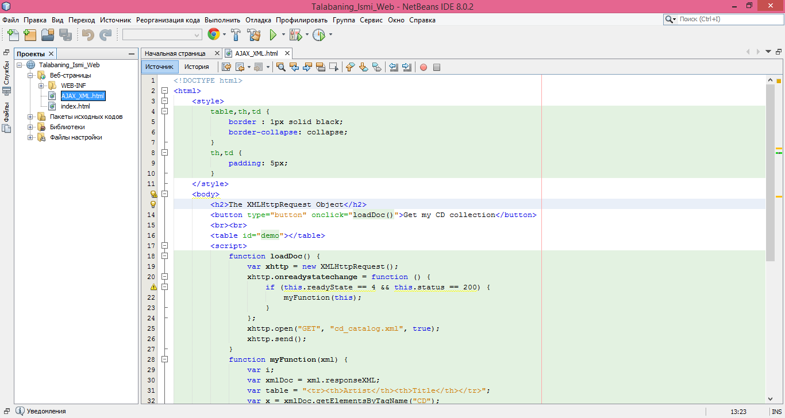
6.10- rasm. NetBeans IDE muhiti AJAX_XML.html fayl tarkibi

Endi cd_catalog.xml faylini yaratamiz. Buning uchun “Веб-страницы” ustiga sichqonchaning o‘ng tugmasi bir marta bosiladi va paydo bo‘lgan kontekst menyudan “Новый → Пустой файл…” tanlanadi.
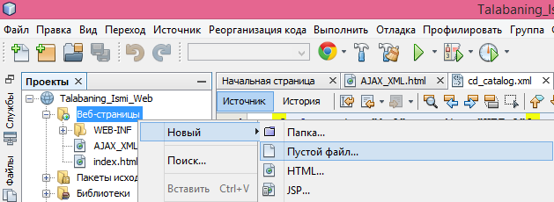
6.11- rasm. NetBeans IDE muhiti fayl yaratish

“New Пустой файл” darchasida “Имя файла” maydoniga “cd_catalog.xml”ni kiritib “Готово” tugmasi bosiladi.
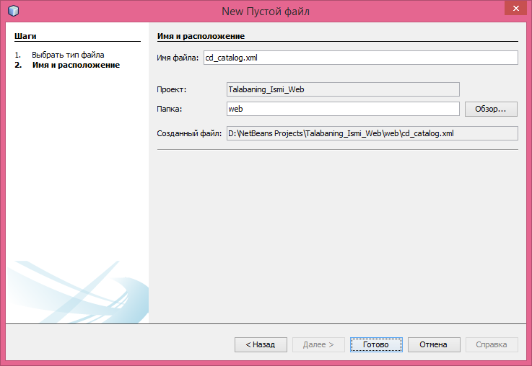
6.12- rasm. NetBeans IDE muhiti cd_catalog.xml faylini yaratish

Yaratilgan “cd_catalog.xml” fayliga XML quyidagi kod kiritiladi.
<?xml version="1.0" encoding="UTF-8"?>
<CATALOG>
<CD>
<TITLE>Empire Burlesque</TITLE>
<ARTIST>Bob Dylan</ARTIST>
<COUNTRY>USA</COUNTRY>
<COMPANY>Columbia</COMPANY>
<PRICE>10.90</PRICE>
<YEAR>1985</YEAR>
</CD>
<CD>
<TITLE>Hide your heart</TITLE>
<ARTIST>Bonnie Tyler</ARTIST>
<COUNTRY>UK</COUNTRY>
<COMPANY>CBS Records</COMPANY>
<PRICE>9.90</PRICE>
<YEAR>1988</YEAR>
</CD>
<CD>
<TITLE>Greatest Hits</TITLE>
<ARTIST>Dolly Parton</ARTIST>
<COUNTRY>USA</COUNTRY>
<COMPANY>RCA</COMPANY>
<PRICE>9.90</PRICE>
<YEAR>1982</YEAR>
</CD>
<CD>
<TITLE>Still got the blues</TITLE>
<ARTIST>Gary Moore</ARTIST>
<COUNTRY>UK</COUNTRY>
<COMPANY>Virgin records</COMPANY>
<PRICE>10.20</PRICE>
<YEAR>1990</YEAR>
</CD>
<CD>
<TITLE>Eros</TITLE>
<ARTIST>Eros Ramazzotti</ARTIST>
<COUNTRY>EU</COUNTRY>
<COMPANY>BMG</COMPANY>
<PRICE>9.90</PRICE>
<YEAR>1997</YEAR>
</CD>
<CD>
<TITLE>One night only</TITLE>
<ARTIST>Bee Gees</ARTIST>
<COUNTRY>UK</COUNTRY>
<COMPANY>Polydor</COMPANY>
<PRICE>10.90</PRICE>
<YEAR>1998</YEAR>
</CD>
<CD>
<TITLE>Sylvias Mother</TITLE>
<ARTIST>Dr.Hook</ARTIST>
<COUNTRY>UK</COUNTRY>
<COMPANY>CBS</COMPANY>
<PRICE>8.10</PRICE>
<YEAR>1973</YEAR>
</CD>

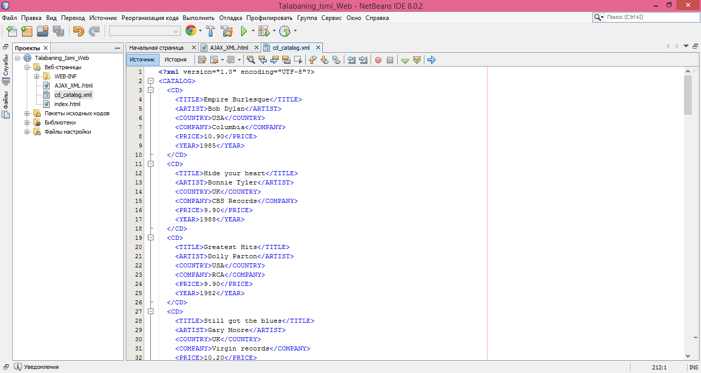
6.13- rasm. NetBeans IDE muhiti cd_catalog.xml fayli tarkibi

Tarmoq dasturini ishga tushirish uchun AJAX_XML.html fayli ustiga sichqonchaning oʻng tugmasi bosiladi va paydo boʻlgan kontekst menyudan “Выполнить файл” tanlanadi.

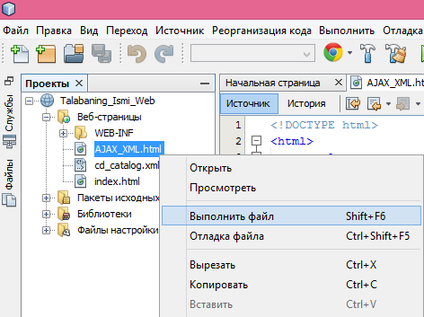
6.14- rasm. NetBeans IDE muhiti AJAX_XML.htmlni ishga tushirish

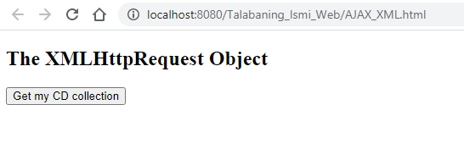
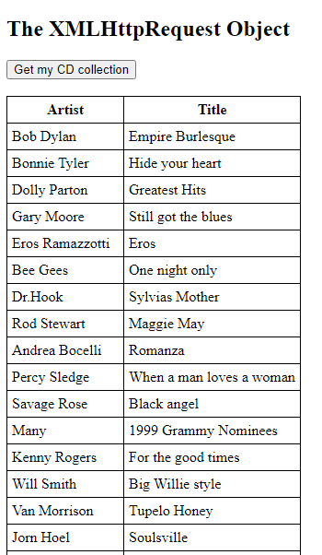
6.15- rasm. Brauzerda natija

Nazorat savollari
- AJAX imkoniyatlari
- AJAXning ishlashi
- XMLHttpRequest obyekti
- Server so‘rovi va javobi
- AJAX XML
- AJAX Database
- AJAX PHP
- AJAX ASP

